*Welcome to Summer Rec 2025!*

*Arundel Parks & Recreation Department*

*Summer Rec Pre-season Parent Information Letter*

**PLEASE TAKE THE TIME TO READ THROUGH THIS NOTICE CAREFULLY**

**This newsletter contains important information about Summer Rec 2025.**

**Updated May 13, 2025**

Dear Parents of Summer Rec 2025 Campers,

Welcome to Summer Rec 2025! We are thrilled to have your children with us for another action-packed season. Many exciting events, activities and field trips have been planned for this summer. We take pride in offering fun, safe, age-appropriate activities for your K-7th graders! **We operate Monday-Friday for children entering grades 1-7, and Monday-Thursday (no Friday programming) for children entering kindergarten.**

I hope this information will be helpful as you and your children plan for the fun-filled summer ahead! I’ve tried to cover all of the FAQs, but by all means, get in touch if you have any further questions after you read through this.

~Jenn Shea, Parks & Recreation Director

# Each Week at a Glance. (This is a typical week, but plans could vary a bit from day to day).

**Mondays** will be our ICE CREAM DAY and we’ll stay at our base camp at Mildred L. Day School. We’ll keep the kids busy with plenty of indoor and outdoor activities such as games, sports and arts & crafts. Ice cream is served at 3pm. All ice cream is $3, and each child is welcome to purchase one. Please send $ in your child’s backpack on Mondays if you’d like your child to get an ice cream. If your child has any dietary restrictions, you are welcome to let us know so that we can buy an option that meets their needs, or send your own ice cream in for them.

**Tuesdays** will be our FIELD TRIP DAY most weeks this summer. We have some great field trips planned for this season including Funtown, Splashtown, Aquaboggan, and more! Most of our field trips are to outdoor venues. If the weather is not great but still conducive to being outdoors, we will try to keep our outdoor plans. If we have an outdoor field trip planned and it is raining, we will switch to an indoor field trip location such as the movies (rated G or PG only), bowling, roller-skating, Urban Air, etc. These decisions are usually made at the last minute.

**Wednesdays** will be our SPECIAL EVENT DAY or BEACH DAY. Special events will include live children’s presentations and entertainment, all-camp scavenger hunts, air band & talent show practice, etc. Beach Days are generally every other Wednesday. We will visit local coastal beaches on our Beach Days. In case of inclement weather on beach day, we will do activities at our base camp instead (please pack for the beach just in case it clears up – we will still go even if it isn’t a “perfect beach day”).

**Thursdays** will be our weekly LAKE DAY. We will go to a variety of lakes & ponds in our region each week. In case of inclement weather, our trip to the lake will be canceled for the week and we will do activities at our base camp instead (please pack for the lake just in case it clears up – we will still go even if it isn’t a “perfect lake day”).

**Fridays (No Kindergarten program on Fridays)** will be our CAMP LUNCH DAY. Fridays will be a day at our base camp at Mildred L. Day School. We’ll keep the kids busy with plenty of indoor and outdoor activities such as games, sports and arts & crafts. For Camp Lunch, which is a fundraiser for the Rec Department’s scholarship fund, we usually offer pizza, chips, pickles and a drink. If you choose for your child to get camp lunch, please pay $7 at drop-off/pick-up or online on our website no later than Thursday. ***Money for Camp Lunch Day will be due by 5:00pm on Thursdays so we can place our large order in advance and shop for the extras the night before.***Because we place our order and shop for camp lunch on Thursday evenings, there will be no refunds if you pay for camp lunch for your child and then they don’t attend that day. Camp Lunch is optional, simply pack a lunch if your child is not signed up. Even if a child is getting camp lunch on Friday, they still need to bring snacks and a refillable water bottle to keep them fueled up for the rest of the day.

**The “Nitty Gritty”**

*Details you need to know…*

Our “Base Camp” at Mildred L. Day School consists of the gym, several classrooms, and the outdoor grounds. We appreciate the generosity and cooperation of RSU 21 in offering us space in their buildings for our programs including Summer Rec.

HOURS/DATES OF SUMMER REC: Summer Rec runs for 8 weeks from Monday, June 23 through Friday, August 15, 2025. Our daily hours are 7:15am-5:15pm. It is not recommended that children stay at Rec for the whole 10 hours that we are open. Summer Rec will be CLOSED on Friday, July 4, 2025 for Independence Day.

DROP-OFF AND PICK-UP: Drop-off will be between 7:15-8:30am and pick-up will be between 3:15-5:15pm daily (see weekly newsletter for field trip return times). To drop your child off and pick them up, please use the bus loop to park and bring your child to/from the door. We would prefer to have all drop-offs & pick-ups during this time frame because we will have a “front desk” staff member this year during those hours only. We will be utilizing our usual sign-in/sign-out method. Children will be released at the end of the day only to their parents or others approved by parents. If our staff doesn’t recognize the person who comes to pick your child up, they will be asked for ID and/or parents will be called to verify if we haven’t received word in advance that this person is allowed to pick up. **Please be sure to update the names of everyone who can pick your child up.** The MLD building will remain locked this year. If you will be dropping off or picking up outside of our designated times, please be prepared for it to take a little bit longer and you’ll need to call (207) 205-6724 and ask someone to meet you. This may take several minutes due to logistics if the front desk member is not with us at the time. If you choose for your child to get ice cream or pizza, please pay online at arundelrec.com or cash at the front desk during drop-off/pick-up. Otherwise, $$ should be placed in your child’s LUNCH BOX for them to turn it into staff. We find that the lunch box is the best place for it (if you aren’t paying online) because kids open and close their lunch box several times a day and will see it there. They don’t always look in their backpacks.

**DISCIPLINE:** Children are expected to behave appropriately at Summer Rec so that it can be a safe and enjoyable summer for everyone. Any behavior that results in a safety concern, is destructive, is disrespectful or harmful to others, is repeatedly disruptive, or is otherwise inappropriate will result in a “Discipline Notice” going home to parents so you can discuss it with your child, sign it, and return it to us the next day. The family will be responsible for any repair or replacement costs associated with destructive behavior. Upon receiving the 3rd discipline notice, campers will have to stay home from camp on the next scheduled field trip day. Upon receiving the 5th discipline notice, campers will be dismissed from Summer Rec for the remainder of the summer -- money will not be refunded. The Arundel Parks & Rec Department reserves the right to dismiss a child from Summer Rec at any point if it is deemed necessary; regardless of the number of discipline notices he/she has received.

**FOOD/DRINK:** Children must come to camp each day with a lunch, two snacks and a refillable water bottle (we prefer water over sweetened drinks…water is the healthiest choice, and sticky spills attract ants!). Here’s a tip to keep the water cold during the day: fill the water bottle and keep it in the freezer the night before. When packing food, please keep in mind that the children are more physically active at Summer Rec than they are during a typical school day, and they will need more food than usual. Even if they register for Camp Lunch, they still need lots of snacks & a refillable water bottle on Fridays. There is no refrigeration available, and we do not have the ability to heat up lunches. Please plan accordingly.

**CAMP T-SHIRTS:** We have replaced our Parks & Rec Trip T-shirts with dri-fit material so they are more comfortable to wear while swimming and to keep kids and staff cooler and more protected on those hot summer days. They are more expensive but we think it will be worth it. Thanks to a grant from the Tommy McNamara Foundation, every camper will receive TWO FREE DRI-FIT SHIRTS. Camp T-shirts will be issued on the day of our first off-site trip of the season. Having everyone in the same color with our logo provides an added safety measure during off-site trips. Camp T-shirts MUST be worn for ALL off-site field trips (Tuesdays, Wednesdays, AND Thursdays). If your child arrives at camp without their Trip T-shirt, a new shirt will be issued and you will be charged $20. For health reasons, we do not offer extra T-shirts to be borrowed. A limited number of extra T-shirts will be available for $20 each if you’d like to purchase any extra T-shirts to cut down on laundry. If you have the old cotton style red Trip T-shirts and would like to use them, you are welcome to do so, however children will be required to wear them while swimming. The cotton style gets heavy when wet so the dri-fit style will be much more comfortable for them to wear in the water.

**FIELD TRIP SAFETY:** Children are always assigned to a counselor on field trips. Sometimes they are assigned a “buddy” within their group as well, when appropriate. The children are not able to leave the group/counselor without being accompanied by a counselor to the bathroom, etc. The Buddy System is a second level of safety. Campers are given a buddy to stay with (within the group) during the field trip. If they lose track of their buddy, it is their job to let the counselor know right away so that the counselor can help locate the buddy. Attendance and head counts are done often to ensure that everyone is present. If we are visiting an amusement park, all children are given the opportunity to ride the rides that we visit. If they indicate that they don’t want to go on the ride, our policy is that they should not be asked again (read: pressured) to ride. A counselor will stay off the ride with anyone who chooses not to ride. Due to fairness issues, we do NOT visit “extras,” like concession stands or arcades, for kids to spend their own money during field trips.

**WATER SAFETY:** On water trips, children are not allowed in the water without several counselors in the water facing the group. When we arrive at a beach, we bring cones and toys. The cones are set up to show the boundaries of our area. Children can play within our boundaries from the sand and into the water. Some counselors will be on the sand and several counselors are stationed at the deepest point in the water that any of our campers can go and they watch to make sure nobody goes deeper than they should. Children are allowed to go into the water to their belly button in calm water (lakes, ponds, pools), and to their knees in the ocean when the water is calm. If they are at their knees when there are no waves, we can expect that the waves will hit at their waist. If children are spoken 3 times about going too deep or being unsafe in the water (jumping or pulling on others purposely), they will be asked to sit out for 5 minutes. If they have to be spoken to again, they will not be allowed in the water for the rest of the day. We take water safety VERY seriously. If you send a life jacket, please attach it to your child’s backpack, and we will make sure they wear it. Children are not allowed to leave our boundary lines without a counselor for bathroom trips, etc. ***Exception to water depth rules: if the members of the oldest group (middle school) are strong swimmers, occasionally, counselors will accompany them to a raft in deeper water at a lake for instance, or in slightly deeper water at the beach***

**WHAT TO PACK FOR CLOTHING:** Please pack a change of clothes, a sweatshirt, and a bathing suit & towel for your child each day. Some field trips may require a bathing suit and towel, and we may play water games on days when we do not go on trips. It is a good idea to write your child’s name in permanent ink in all of their belongings. We will have the kids check the Lost and Found Box throughout the summer. This will be located at the front desk for parents to check as well.

**FOOTWEAR: Sneakers or other similar supportive closed-toe shoes must be worn to camp each day.**

Children will be involved in physical activities during the day, and good shoes are a must. **No sandals, flip-flops, high-heels, boots, or Crocs, etc., please!** If your child wishes to wear something other than sneakers at the beach, please send them to camp in their sneakers with the other shoes packed in their bag, which can be put on when we arrive at the beach. They will need sneakers before and after the beach/lake trips. We start physical activities first thing in the morning, before departing on trips, and again after we return, and supportive shoes are needed to avoid injury.

**SUNSCREEN/BUG SPRAY**: **Please send your child to camp each day with sunscreen and bug spray**

***ALREADY ON.*** Please pack sunscreen and bug spray in each of your childrens’ bags every day, labeled with their name. Siblings cannot share sunscreen and/or bug spray bottles because different age groups are not always in the same place. We will do our best to prevent sunburns and bug bites by reminding and/or helping children reapply sunscreen and bug spray at least once a day. Please send your child with a hat and clothing to protect them from the sun daily, as we will be outside every day that the weather allows. If your child does not have their own sunscreen, a new bottle will be issued and parents will be charged $10. A long-sleeved sun-protective swim shirt is a GREAT idea on beach/lake days because sunscreen has a hard time staying put when kids are swimming. Our new Dri-FIT shirts are not rated for SPF protection, however we do expect them to provide some level of sun protection.

**ILLNESS/INJURY:** For the sake of everyone at Rec, please do not send your child to Rec if they are not feeling well. If your child becomes sick and/or injured while at Rec, you must have someone available to pick them up within 30 minutes, or sooner if possible. Children must be fever-free for at least 24 hours WITHOUT fever-reducing medication, and free from sore throat, excessive fatigue, body aches, vomiting, diarrhea, new cough or nasal drainage. We follow the same rules as the school regarding illness. Please keep in mind that other than basic first aid and CPR training, we do not have designated staff nor appropriate facilities to care for injured or ill children – you MUST have a plan in place for your child to be picked up within 30 minutes if they become sick or injured. Please report illness/symptoms to Jenn via email if you child will be out sick recreationdirector@arundelmaine.org

**MEDICINE:** If your child will require medication while at camp, it must be given to staff at drop-off in its original container with dosage information/schedule on it.

**FIRST AID/SAFETY:** All of our staff members are Heartsaver CPR trained, and we do our very best to keep your children safe every day. If your child has any special medical concerns, diagnoses, severe allergies, etc., please let me know by email so that we can include information in our pre-season staff training about what to look for and how to address it. Depending on the circumstances, we will either call you or let you know at pick-up time if there were any significant bumps, bruises or health complaints during the day at Summer Rec.

**PERSONAL POSSESSIONS:** Children should leave personal possessions such as iPads, cell phones, and other valuable or sentimental toys/electronics at home. These items are disruptive to our efforts to keep the children involved in recreational and group activities, are a source of disagreements, and there is also a risk for huge disappointment if they become lost or stolen. The doors in our buses do not lock. **Please do not send cell phones, smart watches, or other communication devices to Rec with your child. Cell phone/smart watch use by participants is prohibited at Rec.** If there is an emergency, staff members will contact parents directly, and we will allow children to call parents with our Rec cell if they request to do so. If there is an extenuating reason for a child to need to carry a cell phone at Rec, it will need to be cleared by Jenn through a conversation with parents, and children will need to request permission and staff supervision for each use. Cyber-bullying is a serious problem, and we do not want the responsibility of having to police it at Rec. We also want kids to have the opportunity to unplug and PLAY!

.

**EXTRA MONEY:** Every year we get questions from parents regarding whether or not their children should bring extra money on field trip days. For a variety of reasons, **children should not bring money**. We do not visit concession stands even if they are available at our trip locations. We focus our time and attention on the activities available at our field trip locations, rather than standing in line at snack bars. If there is a day when the newsletter says it is ok to send money (quarters to buy grain to feed the animals, etc), if you choose to send $ with your child, please send only a small amount, be sure your child has pockets to carry their money in, and keep in mind that children must be responsible for their own money. Please do not ask our staff to hold it for your child – there are simply too many kids for staff to try to keep track of separate money for each child. Also note that it is possible that they may not have an opportunity to spend it if it creates a fairness issue for other children in their group. It is not fair for children who do not have $$ to have to miss activity time while they wait for others to spend money.

**NEWSLETTER:** Each week by Thursday afternoon, a newsletter will be email blasted and posted on the Summer Rec page of our website to provide you with details about our plans for the upcoming week, including any special attire that may need to be worn for trips (Camp T-shirt, bathing suit, etc…). Please be sure to check our message board in the drop-off loop for special announcements & alternate weather plans during the week. *Please read the weekly newsletter for our trip departure & return times, so that your kids won’t miss the bus, and you’ll know what time we’ll be back.*

**CONTACT INFORMATION:** Email address: recreationdirector@arundelmaine.org goes to Jenn’s phone, and will be responded to at the first opportunity. You can also email Tyler at sportscoordinator@arundelmaine.org If you need to get a more urgent message through to us, Rec staff can be texted or called at 207-205-6724.



**PLEASE READ ON FOR INFORMATION ABOUT OUR WORLD-CLASS 2025 STAFF!**

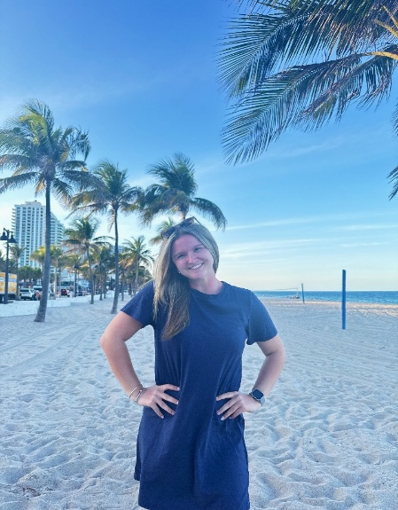Hannah Beaupre (Camp Counselor): Hi! My name is Hannah Beaupre and I am so excited to get the chance to work with your children this summer! I have always had a passion for working with kids, and have more than 5 years of experience in doing so. I have done various internships in Pre-K and second grade classrooms, tons of babysitting, and this is my snior year of college at the University of Southern Maine where I am majoring in Elementary Education to one day have a classroom of my own. While in school, I am working at the Saco School Department as a substitute teacher and educational technician. I also coach and serve on the board of the Biddeford Youth

Cheerleading Program. I live in Kennebunkport with my parents and younger sister, and have a brother who currently lives in Boston, MA. I have the cutest chocolate lab named Xander, and a guinea pig named Gus! In the little free time I have, I love to watch sports (hockey and football specifically), cook, hang out at the beach, and spend time with my family and friends! I look forward to meeting you and your child soon!

Tyler Bernaiche (Assistant Parks & Recreation Director): My name is Tyler Bernaiche and I’m the Assistant Parks & Rec Director along with handling all the youth sports for the community of Arundel. This summer will be my 6th year working for Arundel Rec and I’m looking forward to working with the middle school group this summer. I graduated from Endicott College in Beverly, Massachusetts with a bachelor's degree in Sports Management. Currently I live in Saco with my girlfriend Haley and our two cats, Myla & Bo.

Sports has always been my passion since I was a little kid. I still play basketball multiple times a week with adult pickup basketball on Thursday nights during the summer at MLD with a lot of dads within our community. I enjoy hanging out with my girlfriend, family, friends, and hosting cookouts for football Sundays and UFC Saturdays. My favorite part of my job is helping your children develop passion for sports they love, providing a healthy/safe environment at rec and working for the wonderful community of Arundel. If you ever have a question, feel free to reach out to me. I enjoy talking with the parents of our community.



Kristin Boduch (Recreation Programmer) - I joined the Arundel Parks & Recreation Department last May as the Recreation Programmer. I love to spend time outside going to the beach, kayaking, hiking, camping, and playing a round of mini golf. At home, I have a beautiful cat named Bean. I earned my bachelor’s degree in Exercise Science with a Health Concentration from Keene State College, while playing on the softball team. This coming September, I am beyond excited to be getting married to my fiancé, Michael. I am looking forward to another wonderful summer filled with fun!

Laura Clukey (Camp Counselor): Hi, my name is Laura Clukey. I will be a sophomore at Kennebunk High School in the fall. I live in Arundel with my family and two dogs, Remington & Lucy. My favorite sport is basketball. I have been babysitting kids in my neighborhood for the past couple of years and really enjoy it. I was a camper in the Arundel Summer Rec program when I was growing up, and I’m looking forward to my second summer working in the program. I look forward to spending the summer with your children.



Sofie Dumas (Camp Director): Hi, my name is Sofie! This will be my 6th summer working at Summer Rec and my 2nd as Camp Director. Arundel Rec has always been a part of my life since I was a young camper and I love giving back to this program! I am currently studying nursing at the University of Maine with the goal of becoming a mother/baby nurse! I am certified as a CNA from my clinical experience. Outside of school and Rec, I spend my time staying active, spending time with my family, friends, boyfriend, and 3 dogs, going to the beach/lake, and tutoring other nursing students. I have always enjoyed working with the children of the Arundel community whether it be through the before and after school program, reffing KAK winter basketball, or during summer rec. I cannot wait to spend this summer with your children!

Dominic Gaither (Camp Counselor) - Hi my name is Dominic. I will be a sophomore at Kennebunk High School this fall. I play football and lacrosse and I play for the Kennebunk Rams. I live with my mom, my step dad, my grandparents, and my dog.

Hi, I’m Jessica Hall. I live in Arundel with my husband, 3 children and a silly yellow lab. I have been working in public schools as a social worker for 9 years, and I love working with kids! I am active in the community, as a member of the KAKLL baseball and softball boards, the PTO, and I love coaching my kids’ sports. I enjoy working with the community to bring people together to have fun and enjoy all that Maine has to offer.



Sophia Houle (Camp Counselor) - Hi everyone, my name is Sophia Houle, I’m 16 years old, and I attend Kennebunk High School, where I will be a junior. In the fall, I will also be attending the Health Occupations program at SRTC, where I will be getting my CNA. I also play softball. I’m a third baseman and right fielder. I grew up in Scarborough, Maine, and moved to Kennebunk in 7th grade, where I went to Kennebunk Middle School. I’ve been working at Arundel Rec since the beginning of the 2023-2024 school year. I love working and interacting with all the kids, which is why returning to work at Summer Rec for another summer was such an easy decision. I have a very big family. I have an older brother, 2 little sisters who also attend summer rec, a little brother, and 3 step-siblings. I also have a mini golden doodle, his name’s Teddy, and he has very curly auburn hair. In my free time, I like to go to the beach and relax with my friends. I can’t wait to meet you all and am so excited to have such a fun summer!

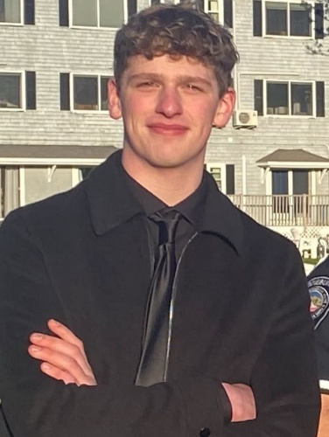

Miles Jacobs (Camp Counselor) - My name is Miles Jacobs, and I will be a senior at The New School this fall. I've been working with Arundel Rec since the fall of 2023, and attended Arundel Rec when I was a kid. When I'm not working with the kids I like to hang out with my older brother, lan, and I enjoy MMA, drawing, hiking, camping and other outdoor activities, and I love to listen to music.

Oneasha Richard (Camp Counselor): Hello! My name is Oneasha, and I'm excited to be returning to MLD camp for my second year, although this time I’ll be working part-time. I have over 8 years of experience working with children from infants to 12 years old. Currently, I serve as an Education Technician at Scarborough schools. I hold a bachelor's degree in Liberal Arts with a minor in Education, which I completed in May 2025. Next fall, I will be enrolled in an Occupational Therapy program to become an Occupational Therapist. I have a cat named Tonka, whom I got last summer. My two nieces are very special to me, and I also have a baby sister now. In my free time, I enjoy playing volleyball, going four-wheeling, and kayaking, along with occasional horseback riding. I especially love spending time outdoors, particularly during the summer.

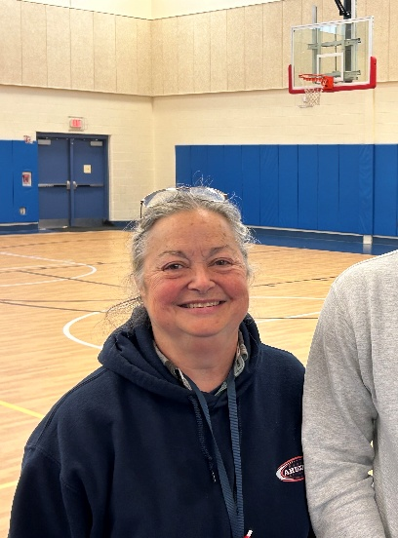Diane Robbins-Mockus (Camp Counselor Check-in/Check-out Coordinator): I have been working at the Arundel Parks & Recreation Department for the last 2 years and have thoroughly enjoyed my time with the children. Before coming to work for the Rec Department, I worked for 10 years in the OR and 32 years in insurance working with medical fraud. I enjoy spending my time gardening, going to car shows, and talking on the phone with my nephew, Ethan, who is at school in Taiwan.



Kristin Robinson (Camp Counselor): I work as a PreK Ed Tech at

Kennebunk Elementary School and have a bachelor’s degree in

English from the University of Maine. I taught dance at Sharon Lux School of Dance for 20 years. I like to spend my free time playing pickleball, golf, reading, and traveling. My husband and I have 2 grown children (twins!). This is my 11th summer working at Summer Rec. I served as Camp Director several years ago, and I am returning for my 5th year as a camp counselor.

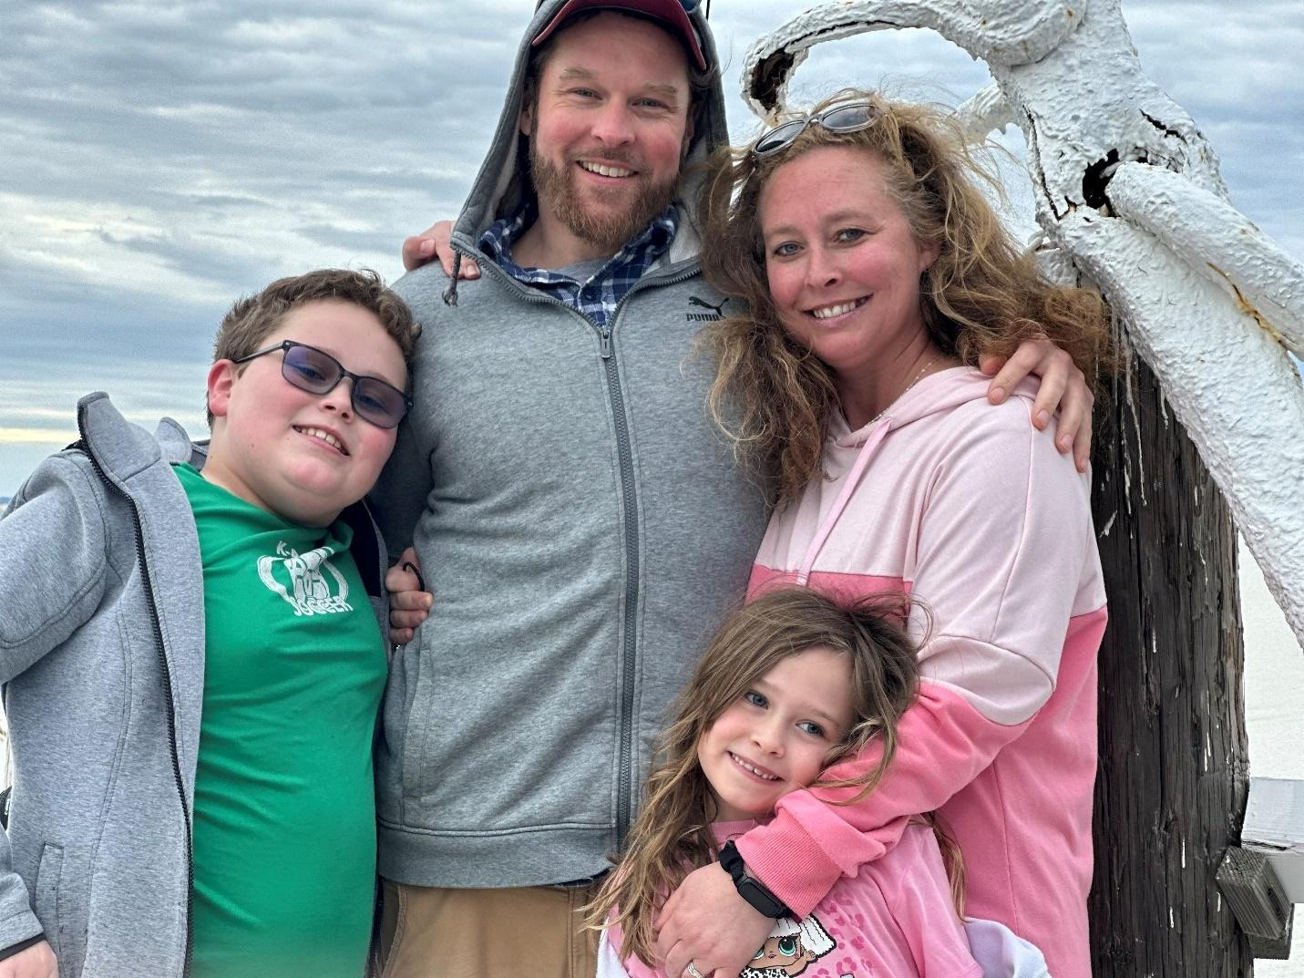

Brooke Tardiff (Camp Counselor): I have worked in the RSU 21 school district for 21 years, and this will be my second season working in the Summer Rec program. I bring my experience and love for daily adventure to my job every day. I have two children in the district, and look forward to returning for another summer filled with fun, friends and play.

Jenn Shea (Parks & Recreation Director): This year marks my 23rd year as Parks & Rec Director for the Town of Arundel. I am looking forward to another fun-filled Summer Rec season with your children and our top-notch staff! I have a bachelor’s degree in English from the University of Southern Maine. I am a Registered Maine Guide and also have a bus license, so you’ll see me behind the wheel of the Rec bus driving the kids to fun places both near and far. Over the past few months, I’ve been training some new bus drivers…you might see Tyler or Kristin behind the wheel of the big Rec bus soon! My husband and I have 4 adult daughters and 1 son-in-law. We welcomed our first grandchild, Lillian Jane, in March of 2025 and we are over the moon to have a baby granddaughter to love. We have 3 dogs, 2 cats, a flock of chickens, and a duck named Chuck. Many of my hobbies are tied to our farm here in Arundel, and our family. I enjoy being outdoors, dog training, exploring, and traveling, especially to the Camp Lejeune area of North Carolina where Baby Lillian lives with her Mom and Dad, who serves in the US Navy, (our daughter and son-in-law)!

Dan Sherman (Camp Counselor): Dan Sherman (Camp Counselor): I live right here in the wonderful town of Arundel with my two daughters, Grace and Ramona, who are students at ML Day and Arundel Rec participants. We have two cats, Leo and Coco, that like to sleep on our heads. I teach 8th Grade Social Studies at the Middle School of the Kennebunks, and also have education and experience in Special Education, Counseling, and Culinary Arts. I love to be outside. I like hiking, swimming in the ocean, playing sports (especially baseball, basketball, and ultimate frisbee). I love to cook, grow food in our garden, and read a good book. I also LOVE music, listening and playing. I am super psyched for a summer full of fun and adventure with the awesome kids of Arundel! This will be my second summer working for Arundel Rec.

Noah Tarring (Camp Counselor): Hi everyone my name is Noah Tarring. I am a graduate of Kennebunk High School as of June 2025. I am a three-sport athlete in Basketball, Golf and Tennis. I grew up in Waterboro and moved to Arundel in 2019. I have two younger brothers, Isaac (15) and Luke (13), and an 8-year old dog named Oscar. I plan to major in Architectural Design and hope to earn my Masters in Architecture. Some of my favorite hobbies are drawing, gaming, and the beach. This will be my third year as a camp counselor at Arundel Rec and I am super excited. The last two summers I have worked primarily with the 3rd, 4th and 5th graders and have had a great time. Keeping the kids active and making them laugh and putting a smile on their faces made my day. I’m excited for another great summer with the kids. See you all soon



Jeff Wolfahrt (Camp Counselor): I am Jeff Wolfahrt, this is my 2nd season working as a camp counselor for Arundel Rec, which I am very excited about. I live in Biddeford with my wife, and our four children, 3 boys and 1 girl. Two are in college, one works full-time and our daughter attends Biddeford High School. I work at The Middle School of the Kennebunks in the special education department. I enjoy working out, listening to music and attending all types of sporting events with my family. I also coach varsity football at Biddeford High School, girls’ basketball at The Middle School of the Kennebunks, as well as being a former High School Lacrosse coach and current Lacrosse Official. I look forward to having another amazing summer.